**SmartAgCloud**

**Design Document**

CMPE 281

Spring 2019

Professor:

**Jerry Gao <Jerry.gao@sjsu.edu>**

**Term Project Id - Team 1**

**Hemaprasanthi Mutyala <hemaprasanthi.mutyala@sjsu.edu>**

**Maahi Chatterjee <maahi.chatterjee@sjsu.edu >**

**Wenyan He <wenyan.he@sjsu.edu>**

**Lakshmi Kameswari Maduri <lakshmikameswari.nishthala@sjsu.edu>**

**Table of Contents**

**Table of Contents.................................................................................................................1**

**1 Introduction.....................................................................................................................4**

**1.1 Rationale...................................................................................................................... 4**

**1.2 Objectives…………….............................................................................................…...4**

**1.3 System overview………………………………............................................................... 4**

**1.4 Product Scope and actors...........................................................................................4**

**1.5 Outcome………………………………………………………………………………………..4**

# **1. Introduction**

## **1.1 Rationale**

Smart AgCloud is an IOT-based smart agriculture infrastructure service management system as a service on a cloud. It supports large-scale IOT-based agriculture system infrastructure services for farmers allowing them to have more control over their farm with less human effort and more promising results by predicting the future through real time data from sensors deployed in the field. Each farmer could select install and deploy one or more IOT agriculture networks for their greenhouses or ranch fields. To achieve that, an infrastructure at a unit level is required. This infrastructure should collect, store and process information at the most fundamental level of operation. The IOT-based smart agriculture infrastructure management system encapsulates this logical premise and provides an autonomous agriculture system.

## **1.2 Objectives**

A smart agriculture uses different types of electronic data collection sensors to supply information which is used to manage each part of the ranch efficiently, cultivate different crops in a regulated environment and predict the future through the data from different sensors. The purpose .The goal here is to create a system that gets various readings from sensors installed on fields for research like humidity prediction, moisture control, soil nutrition calculation, and used for various commercial level applications. The major objectives can be listed as:

* Sensor installation, registration and tracking
* Data collection from sensors, nodes and data management
* Data analysis and report generation
* Protected data access to different uses

## **1.3 System Overview**

This project is designed to develop, implement, and validate an IOT-based cloud infrastructure system as a SaaS for Smart Streets in a smart city. Each smart street is a smart node equipped with a set of sensors. Each smart node is in turn connected to a cluster which will be used to control the connected smart nodes and support the communications with the back-end server to send the collected sensor data for all nodes. Each smart node has wireless communication capability which supports node-to-cluster communications.

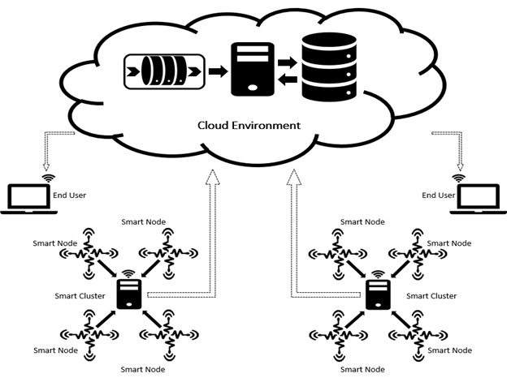

Figure : System Overview

## 

## **1.4 Product Scope and Actors**

The designed product would be able to implement a scalable distributed system which provides support to efficiently retrieve, maintain and update sensor data of the various (nodes) via a cluster node which is connected to a database server in a cloud-based simulation system.

The intended actors for the smart agriculture system are farmers since they are the primary owners of the field who cultivate different crops, IOT Supports because they check the sensor availability, and IOT Manager since he governs communication between several sensors, nodes and databases. The intended actors can be government agencies who would require information to enhance their countries income through detailed evaluation of the crop’s status. This system can also be provided as a service to commercial units such as pesticides agencies, local entrepreneurs and many more, who want a complete analysis of the area for better crop management. This system includes the following types of users:

* **Farmer** - Can access the system to check and configure their own IOT networks with smart nodes (with diverse sensors) online by accessing SmartAgCloud to check their IOT sensor status and statistic data – The persons who access the system to find out the status of smart nodes and sensors.
* **IOT Supports** – Can access the system to find out the status of smart nodes and sensors.
* **Infrastructure manager** – Can setup, configure, and manage smart nodes, cluster nodes, and sensors, as well as their connections.

## **1.5 Outcomes**

This system outcome generates profit not only farmers but also for the country as a whole. The system enables to reduce the human effort by representing the required data digitally from sensors. The output of this system provides farmers with the information of different aspects of the field like moisture, sunlight, soil nutrition level to have full control of their field so as to configure the requirements as per the type of the crop cultivated.

This system gives the flexibility to add more sensors or nodes if required. IOT Support has the responsibility of the sensor’s health. They can check the sensors availability through heart beats and take required actions immediately. The data flow is governed by Infrastructure manager. Hence the whole system is well developed with shared responsibilities. Irrespective of the experience of the farmer and human effort each one can grow the crops with little knowledge on farming.  The IoT generates massive amounts of data, and cloud computing provides a pathway for that data to travel to its destination. It eliminates the cost of maintenance for data bases, servers.